HUman Eye - 02
CLASS 10 - SCIENCE

 | Section A
1 | In the following diagram the correctly marked angles are: 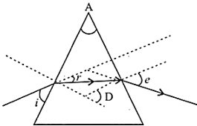  a) $∠$ A, $∠$ i and $∠$ e  b) $∠$ A, $∠$ r and $∠$ D  c) $∠$ i, $∠$ A and $∠$ D  d) $∠$ A and $∠$ e | [1]
2 | In the following ray diagram the correctly marked angles are: 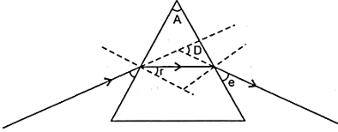  a) $∠$ i and $∠$ e  b) $∠$ r, $∠$ A and $∠$ D  c) $∠$ i, $∠$ e and $∠$ D  d) $∠$ A and $∠$ D | [1]
3 | Study the following figure in which a student has marked the angle of incidence ($∠$ i), angle of refraction ( $∠$ r), angle of emergence ( $∠$ e), angle of prism ( $∠$ A) and the angle of deviation ( $∠$ D). The correctly marked angles are: 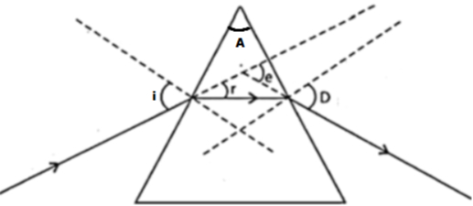  a) $∠$ A, $∠$ i and $∠$ r  b) $∠$ A, $∠$ i, $∠$ r and $∠$ D  c) $∠$ A, $∠$ i and $∠$ D  d) $∠$ A and $∠$ i | [1]
4 | Study the following ray diagram 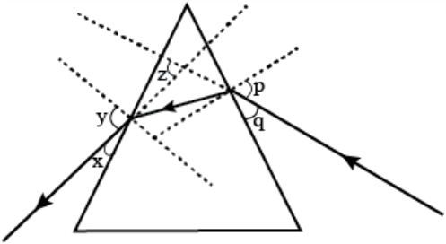  In this diagram, the angle of incidence, the angle of emergence and the angle of deviation respectively have been represented by:  a) p, y, z  b) y, p, z  c) x, q, z  d) p, z, y | [1]
5 | What is the relation between angles 1, 2, 3 and 4? 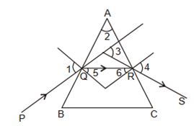  a) + = +  b) + = +  c) + + = +  d) + = + | [1]
 | Section B
6 | Match the following: 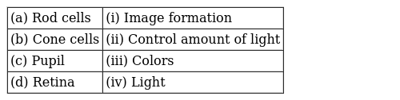 | [2]
7 | Match the following: 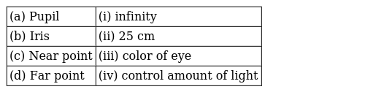 | [2]
8 | Match the following: 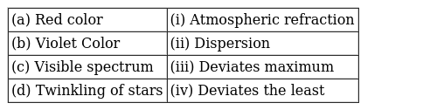 | [2]
9 | Match the following: 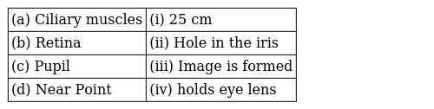 | [2]
10 | Match the following: 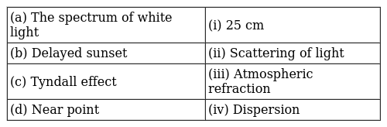 | [2]
11 | Match the following: 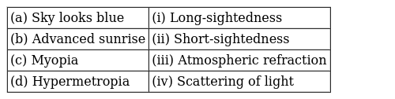 | [2]
12 | Match the following: 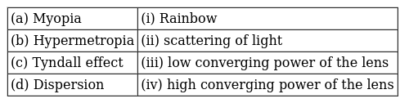 | [2]
13 | Match the following: 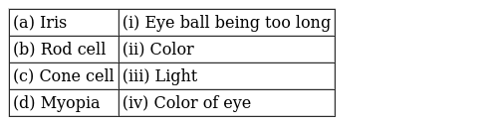 | [2]
14 | Match the following: 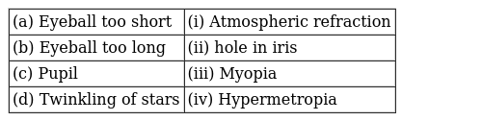 | [2]
15 | Match the following: 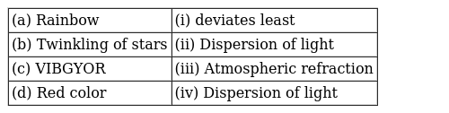 | [2]
16 | Match the following: 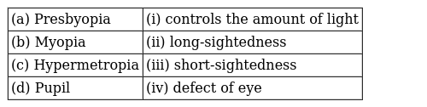 | [2]
17 | Match the following: 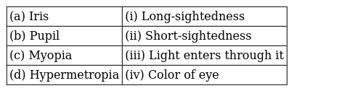 | [2]
18 | Match the following: 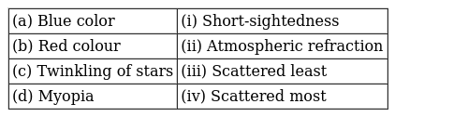 | [2]
19 | Match the following: 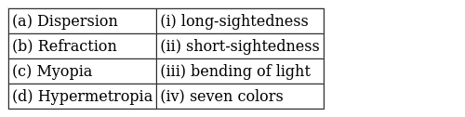 | [2]
 | Section C
20 | If Ram, a myopic person uses spectacles of power - 0.5 D, then what will be the distance of far point of his eye? | [1]
21 | What is scattering of light? Why does the clear sky appear blue? | [1]
22 | While doing the experiment to trace the path of rays of light through a glass prism what should be done in the beginning of experiment and why? | [1]
23 | Name the principle on which a prism form the image of an object? | [1]
24 | What happens to the lens and the ciliary muscles when you are looking at nearby objects? | [1]
25 | A narrow beam XY of white light is passing through a glass prism ABC as shown in the diagram: 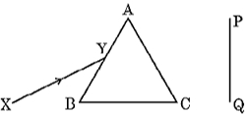  Trace it on your answer sheet and show the path of the emergent beam as observed on the screen PQ. Name the phenomenon observed and state its cause. | [1]
26 | What do you mean by a rainbow? | [1]
27 | Define power of accommodation? | [1]
28 | Which phenomenon is responsible for increasing the apparent length of the day by 4 min? | [1]
29 | Where is the image formed in an eye suffering from long sightedness? | [1]
30 | What is the relation between intensity of scattered light and its amplitude? | [1]
31 | What would have been the colour of the sky, if the Earth had no atmosphere? | [1]
32 | Why are dangerlight signalsred in color? | [1]
33 | In which direction a ray of light bends while emerging out of a prism? | [1]
34 | When sunlight enters a dark smoke filled room, its path becomes visible. Name the phenomenon responsible for this. | [1]
35 | It is observed that the power of an eye to see nearby objects as well as far off objects diminishes with age.  - Give reason for the above statement.  - Name the defect that is likely to arise in the eyes in such a condition.  - Draw a labelled ray diagram to show the type of corrective lens used for restoring the vision of such an eye. | [1]
36 | Which component of white light is least scattered by fog or smoke? | [1]
37 | A person needs a lens of power –4.5 D for the correction of her vision. What is the focal length of the corrective lens? | [1]
38 | Variable focal length of the eye lens is responsible for which property of eye? | [1]
39 | In the following ray diagram which angles are properly labelled and what do we call these angles? 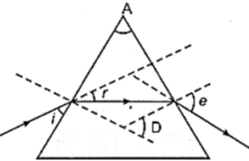 | [1]
40 | The diagram shows radiations from a lamp passing through a prism. 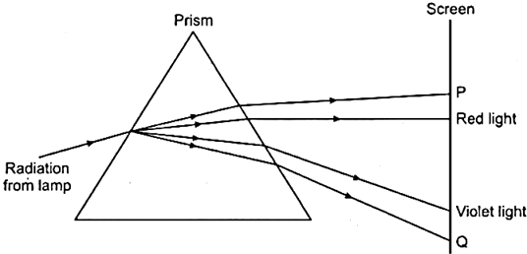  Which type of radiations are found at P and Q? | [1]
41 | Bees are able to see ultraviolet light. Comment. | [1]
42 | The colour of clear sky from the earth appears blue but from the space it appears black. Why? | [1]
43 | Name the part of the eye:  - that controls the amount of light entering into the eye.  - that has real, inverted image of the object formed on it. | [1]
44 | Name the part of our eyes that helps us to focus near and distant objects in quick succession. | [1]
45 | Which part of the human eye conveys the electrical signals generated by the light sensitive cells of the retinato the brain? | [1]
46 | Though a hot iron emits radiations, yet it is not visible in the dark, why? | [1]
47 | Observe the following diagram and answer the questions following it: 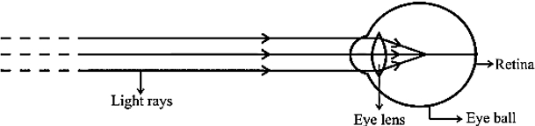  - Identify the defect of vision shown.  - List its two causes.  - Name the type of lens used for the correction of this defect. | [1]
48 | What is the function of the liquid filled in the space between the eye lens and retina? | [1]
49 | What is the function of the crystalline lens of the eye? | [1]
50 | A person is advised to wear spectacles with convex lenses. What types of defect of vision is he suffering from? | [1]
51 | On whichfactor does the color of the scattered light depends? | [1]
52 | How can you identify the type of defect of vision a person is suffering from by physically touching his spectacles? | [1]
53 | A man is wearing glasses of focal length +1m, what can be defect in the eye? | [1]
54 | Why is the colour of the clear sky blue? | [1]
55 | Name the factor on which the colour of light depends? | [1]
56 | Where do we see the following lenses in a bifocal spectacle?  - concave lens  - convex lens | [1]
57 | Where is the image formed in an eye suffering from near - sightedness? | [1]
58 | A person needs a lens of power –4.5 D for the correction of her vision. What is the nature of the corrective lens? | [1]
59 | When and where does a rainbow appear in the sky? Draw a labelled ray diagram to show its formation. | [1]
60 | Mala can see the objects lying between 25 cm and 100 cm from her eye. Her vision can be corrected by using lens of power - 0.1 D. Is the statement true or false? | [1]
61 | A person needs a lens of power –4.5 D for the correction of her vision. What kind of defect in vision is she suffering from? | [1]
62 | If the far point of Raju, a myopic person is 4 m, then how would you calculate the power of the lens he requires to look at the stars? | [1]
63 | A piece of cloth appears red in sunlight. How will it appears when held in the blue portion of a spectrum? | [1]
64 | Which part of the human eye provides most of the refraction for the light rays entering the eye? | [1]
65 | Why do we observe difference in colours of the Sun during sunrise, sunset and noon? | [3]
66 | When one enters a less lighted room from a place of intense light, he is not able to see anything for sometime, but after sometime the things become somewhat visible. Explain how this happens? | [3]
67 | - Write the function of each of the following parts of human eye : cornea, iris, crystalline lens, ciliary muscles.  - Millions of people of the developing countries of world are suffering from corneal blindness. These people can be cured by replacing the defective cornea with the cornea of a donated eye.A charitable society of your city has organised a campaign in your neighbourhood in order to create awareness about this fact. If you are asked to participate in this mission how would you contribute in this noble cause?  - State the objective of organising such campaigns.  - List two arguments which you would give to motivate the people to donate their eyes after death.  - List two values which are developed in the persons who actively participate and contribute in such programme. | [3]
68 | - State two main causes of a person developing near - sightedness. With the help of a ray diagram, suggest how he can be helped to overcome his disability?  - The far point of myopic person is 100 cm in front of the eye. Calculate the focal length and power of a lens required to enable him to see distant objects clearly. | [3]
69 | A camera in many ways is similar to the human eye, still, there are some basic differences in image formation between the two. Explain. | [3]
70 | How can changes of size of eyeball be one of the reason for  - myopic and  - hypermetropic eye?Compare the size of eyeball with that of a normal eye in each case. How does this changes of size affect the position of image in each case? | [3]
71 | A student sitting at the back of the classroom cannot read clearly the letters written on the backboard. What advice will a doctor give to her? | [3]
72 | Why do different rays deviate differently in the prism? | [3]
73 | A narrow beam PQ of white light is passing through a glass prism ABC as shown in the diagram. 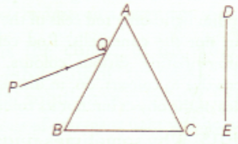  Trace it on your answer sheet and show the path of the emergent beam as observed on the screen DE.  - Write the name and cause of the phenomenon observed.  - Where else in nature is this phenomenon observed?  - Based on this observation, state the conclusion which can be draw about the constituents of white light. | [3]
74 | What are the common defects of vision that can be corrected by the use of suitable eyeglasses or spectacles? | [3]

